
Ren Fu, Ph.D. He is engaged in teaching, theoretical research and application development on cartography, mapmaking, multimedia atlas, mobile GIS.
STUDY ON CONVERSION FROM SPATIAL INFORMATION TO NATURAL LANGUAGE
Fu. Ren¹, Qingyun. Du¹
1 School of resources and environmental science, wuhan university, LuoYu Road 129, wuhan, hubei province, china
{ renfu, qydu }@whu.edu.cn
Abstract. The author argues that theories of spatial conception in linguistics and linguistics model of spatial information help ground a conversion from spatial information to natural language, and technologies of Geographic Information System (GIS) and Natural Language Generating (NLG) attempted to provide or account for aspects of methods of implementing the conversion. The conversion is not only feasible, but provides spatial information services with new and perhaps more sophisticated formalisms. In the paper, based on the metaphor of spatial information as natural language that is one of the basic human communication tools, the macroscopic research achievements including spatial conception related to natural language and theories related to spatial information model are summarized, and the microcosmic methods with respect to object-based spatial model and NLG are generalized.
Keywords: Spatial Information, Natural Language Generation, Intermediate Semantic Model, Spatial Relation, Spatial Scene Description

1 Introduction
Map and linguistics are two traditional disciplines. Spatial information and natural language are two individual symbol systems to describe objective world. As an equivalence of human spatial experience, spatial information and natural language can be used to get at principles of graphic symbols and literal symbols separately. With the development of cognitive science and information technologies, links between spatial information and natural language are enriched. For a long time, map is regarded as a sound formal media that interchanges information between spatial information and natural language.
From a macro perspective, the common foundation between spatial information and natural language is cognitive science and computability. On the one hand, spatial cognition is based on the belief and knowledge of cognitive science, and forms an important part of cognitive science. On the other hand, cognitive linguistics should contribute to the development of fundamental theory in cognitive science. Although symbol characters of spatial information and natural language are significant difference, its essences are most relevant to the regularity of cognitive science. In essence, computability of spatial information raises spatial information model and spatial relation theory in general. Computability of natural language uses computer implementations as a method for Natural Language Processing (NLP), which is a branch of Artificial Intelligence (AI), and includes two opposite but tightly related processes: Natural Language Understanding (NLU) and Natural Language Generating (NLG).

2 Background
Based on spatial azimuth in modern Chinese, many modern Chinese linguists proposed and analyzed systematically research achievements including location, shape and direction, which are represented by natural language sentences. Location indicates spatial characteristics, which is generated by location change between one entity and another referenced entity in natural language sentences, and is divided into static and dynamic. Static location and dynamic location have respective features in the aspect of natural language syntax representation. Direction is represented by azimuth lexicon and reference points, and indicates spatial characteristics generated by entities’ oriented direction in natural language sentences. Variety of Direction description has the original source of semantic difference of azimuth lexicon and choice difference of reference points, and therefore azimuth lexicon can be classified as horizon (absolute and relative), vertical and radial in general. Choice of reference points is from a range of first, second and third. Shape indicates space scope which entities occupy in natural language sentences, and space scope is a kind of geometrical graphic generalization of entities’ location, and includes point, polyline, polygon and polyhedron. Representation of shape focuses on azimuth lexicon.

3 Intermediate Semantic Model
Cognitive Psychology distinguishes two spaces: physical space and cognition space. With respect to linguistics, there exists third space: language space. It is important to give a clear semantic conversion framework from spatial information to natural language. From a semantic perspective, Intermediate Semantic Model (ISM) is introduced, and forms a reversible transition as semantic foundation between spatial information and natural language (see Fig.1), and joints both features at deep level, and helps to solve the contradiction between universal approaches and concrete contents. ISM involves semantic abstract and semantic expansion. Semantic expansion means supplement to spatial object without changing its geometric features. Semantic abstract is to seek effective method for building compound spatial object consisting of simple point, line, surfaces and so on by means of reference, generalization, aggregation, combination, classification and constraint so as to represent geospatial concept.
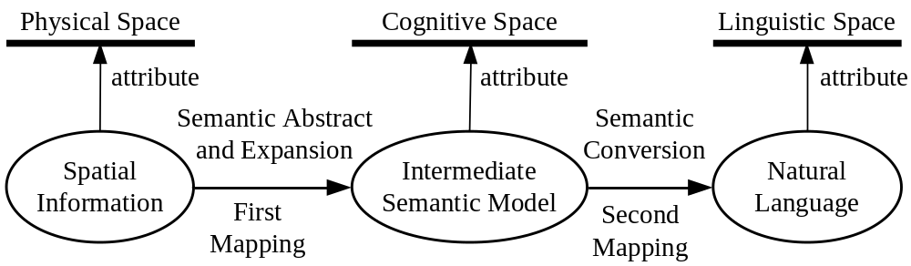
Fig. 1 Three-level structure and two-level mapping

3.1 Spatial Point of Interest
Spatial Point of Interest (SPOI) is just such a compound object class. SPOI represents cognitive and semantic knowledge, constructs basis of spatial query and analysis, erects a bridge for conversion between spatial information and natural language, and is quite different from landmark and hotspot. Landmark focus more on geographic meaning and spatial relation, can be memorized and distinguished from numerous directions, is used to locate geographic object nearby and identify some special object, and represents declarative knowledge. Hotspot represents hyperlink in hypermedia model. With respect to SPOI, a variety of content including conception, categories, acquisition method, object oriented model, semantic and semantic relation should be researched and analyzed systematically. But its object oriented model is core and is introduced in detail.

3.2 Object Oriented Model of SPOI
Object oriented Model of SPOI (SPOI object) emphasizes semantic completeness (see Fig.2).
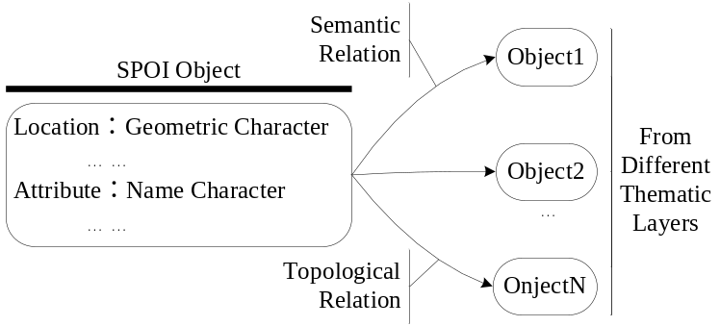
Fig. 2 object oriented model for SPOI
Therefore SPOI object is characterized by following:
- Identification division, are only identifier in database.
- Semantic relation, constrain and influence spatial relation.
- Feature Identifiers, as point object set, are crucial to be in concordance with people’s recognition and acceptance.
In addition, related efforts are characterized by a growing interest in the representation of data structure and computational rule of spatial relation to SPOI object. We proceed as follows:
- Providing knowledge base to represent semantic of SPOI object.
- Defining computational rules in coordination with traditional spatial analysis between feature identifiers (point set) from separate SPOI object.
- Constructing global data dictionary to represent rules between semantic relations.
- Pointing towards a novel way of text generation.

4 Conversion Framework and Implementation

4.1 Conversion Framework
From a syntax perspective, formal framework is established (see Fig.3). It is syntax basis for conversion from spatial information to natural language, and maps both features based on ISM. From linguistic view, architecture comprised of semantic feature, semantic feature sets, entity, entity sets and spatial relation, spatial scene makes up of similar hierarchical structure which consists of lexicon, phrase, sentence, composite sentence, sentence sets. It sets up a fundamental linguistic reference model at various levels of syntax for the conversion.
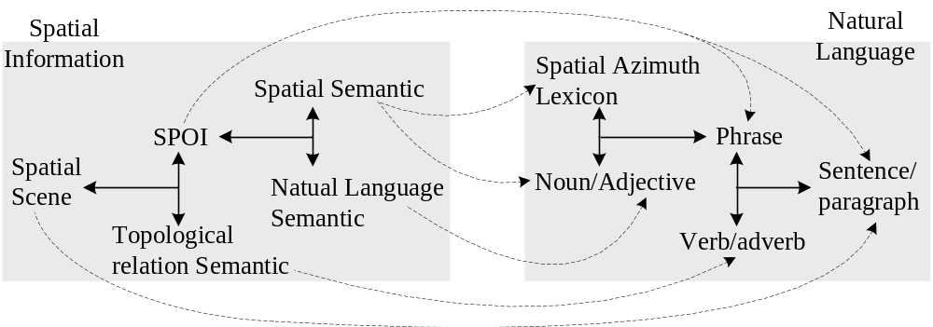
Fig. 3 Conversion Framework

4.2 Automated Scene Description
From a form contrast perspective, spatial theme can be represented by natural language as well as by spatial information. Two disciplines have developed separately in the last years, but constructed corresponding semantic basis in recent years (see Fig.4).
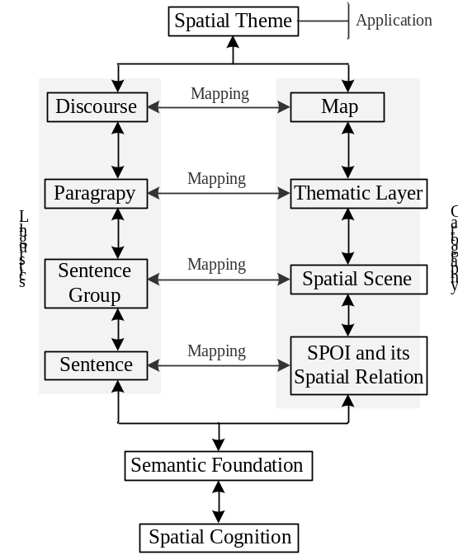
Fig. 4 Form contrast between linguistic and cartography
From a technical implementation perspective, methods of spatial scene description and route description are explored based on knowledge base, computational rules, data dictionaries and text generation. Meanwhile, knowledge base presents facts of SPOI. Based on theories of spatial relation among spatial objects, computational rules emphasize spatial relation including location, distance, direction and topology among SPOI. Global data dictionary offers rich knowledge and its guide rules so as to fulfill the need of text generation. Text generation adopts schema method and template method. Spatial scene description is composite by many schemas and templates. Route description contains surface meaning and deep-level meaning.

4.3 Example “Bus Route Finding”
Bus route finding is a crucial element for the task of public web map services, and can be queried by several different approaches between SPOI objects. It is important to note, results are represented by natural language (see Fig.5).
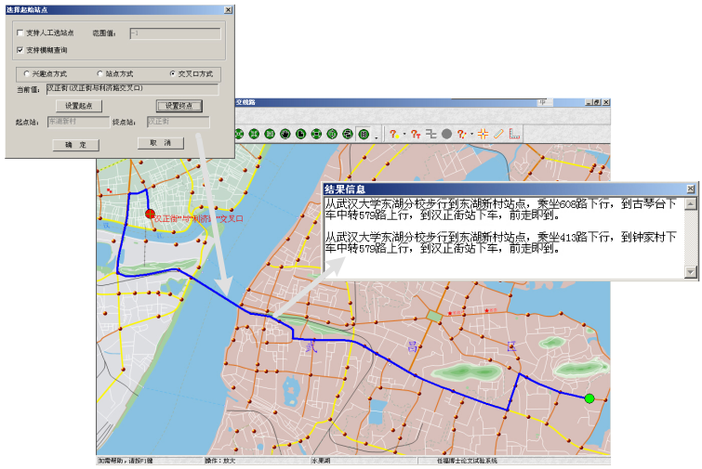
Fig. 5 Bus route finding instance

5 Conclusions
A central goal in conversion is to create ISM which represents the rich semantic knowledge needed for organizing and using spatial information and natural language. In recent years, much work has been invested in developing text generation algorithm automatically. However, the semantic relations between spatial information and natural language have not been grounded in a formal theory. As a result, we outline a conversion framework for the representation of spatial cognition and put it down to experience.

References
- Mark D M, 1999. Spatial representation：A cognitive view. Maguire D J, Goodchild M F，Rhind D W，etal . Geographical Information Systems：Principles and A pplications. New York : John Wiley &Sons, 81 - 89
- Frank, A. U. & Mark，D. M. 1991.Language issue for Geographic Information Systems, in: Geographic Information System: Principles and Applications, edited by David Maguire et al., New York, NY: Longman Scientific & Technical
- Frank, A. U. 1991. Qualitative Spatial Reasoning about Distances and Directions in Geographic Space. Journal of Visual Languages and Computing, 3:343-371.
- Chris Mellish and Xiantang Sun, 2003. The semantic web as a Linguistic resource: Opportunities for natural language generation, Knowledge-Based Systems, Volume 19, Issue 5, September 2006, Pages 298-303
- Ligozat, G.., 2000. From Language to Motion, and Back: Generating and Using Route Descriptions. In Christodoulakis, D. (ed). Natural language processing, Proc. of the 2nd Intl. Conf., June 2000, Patras, Greece. Heidelberg: Springer Verlag
- Edward Munnicha, Barbara Landaub, Barbara Anne Dosherc, 2001. Spatial language and spatial representation: across-linguistic comparison.. Cognition pp171±207
- Jacek Marciniak and Zygmunt Vetulani, 2002. Ontology of Spatial Concepts in a Natural Language Interface for a Mobile Robot. Applied Intelligence, pp271–274
- Constanze Vorwerg, 2003. Use of Reference Directions in Spatial Encoding, Spatial Cognition III, LNAI 2685, pp. 321–347
- Proceedings of the 10th European Workshop on Natural Language Generation (ENLG-05),Aberdeen, Scotland, 8-10 August, 2005
- Ehud Reiter, Somayajulu Sripada, Jim Hunter, Jin Yu and Ian Davy. Choosing words in computer-generated weather forecasts. Artificial Intelligence, Volume 167, Issues 1-2, September 2005, Pages 137-169

